

Pathway Construction

Works are due to begin from 14th September to construct surfaced pathways. The works are expected to take 4-6 weeks.

The works will resurface the existing Easy Access Route, build a boardwalk around the Spanish Chestnut and create new surfaced paths linking to Queen Street and Blackwells car parks.

Sections of paths will be temporarily closed with diversions in place. Construction areas will be sectioned off to allow for works.

Please be aware there will be additional vehicles around the common. Please follow all safety notices and instructions.

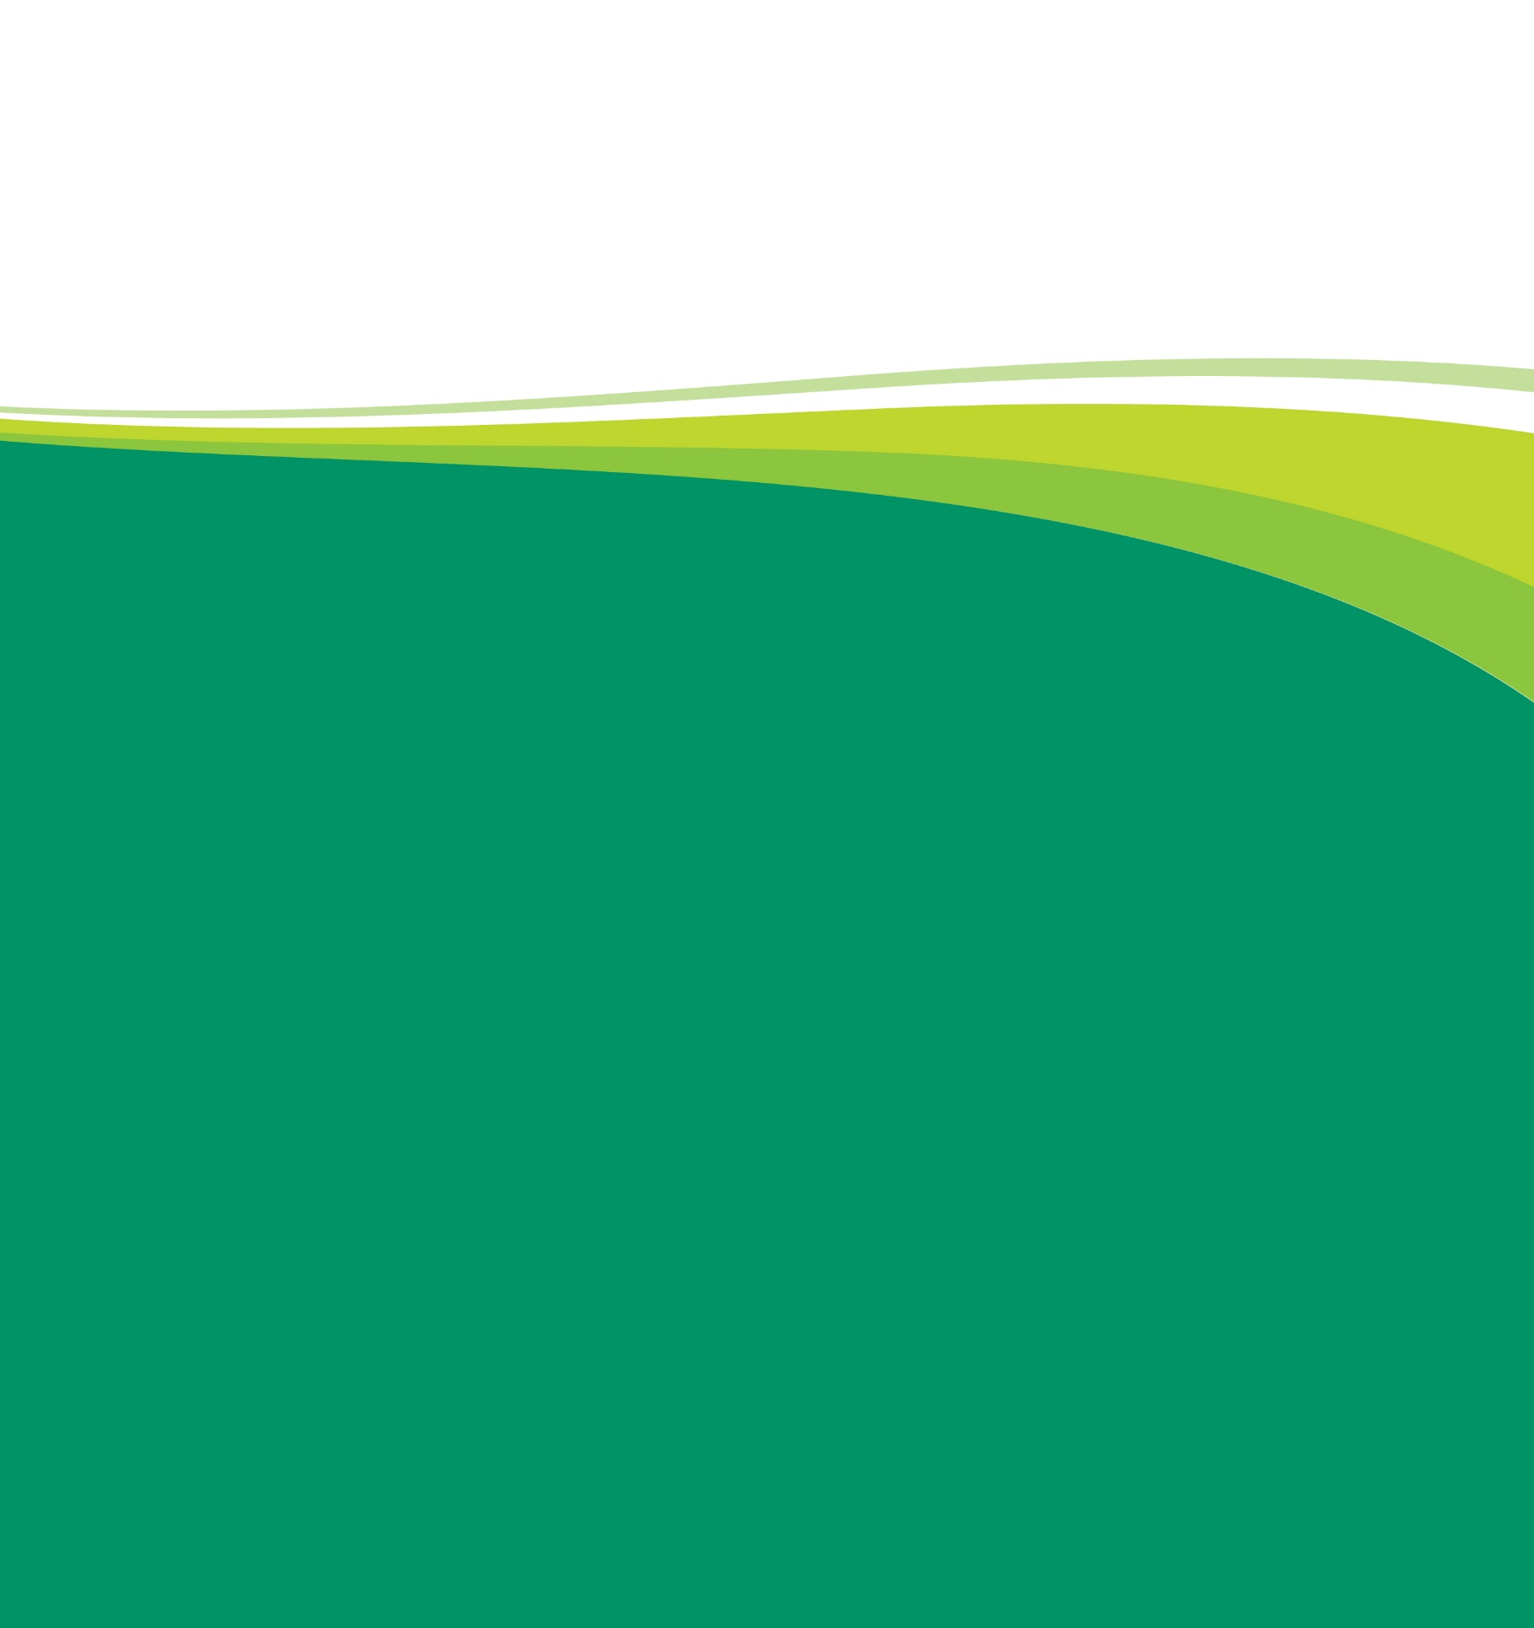
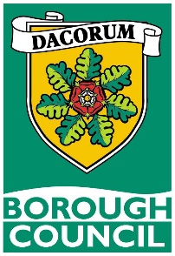

We apologise for any inconvenience.
Works to improve this site for visitors and wildlife are being undertaken as part of its Suitable Alternative Natural Greenspace (SANG) Management Plan. For further information on SANG enhancements please scan the QR code.

